Modifying an html page using Firefox Dev tools is easy.

1. First, open Firefox and navigate to the desired web page. In this example we use: https://content.bellevue.edu/cst/WEB/WEB230/week-9/exercise-9.3.html
2. Press F12 to open the html script.
3. Make sure Elements is selected at the top left of the script window. Click the Styles tab if it is not already selected.
4. Hover through the code until you have found the element on the web page you wish to change. The web page will highlight the elements as you hover of their code. For this exercise, locate the <header> tag, and click the dropdown arrow to the left of it. 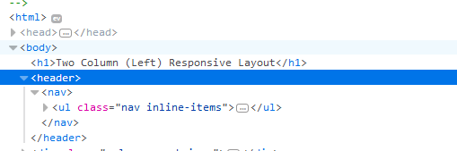
5. You’ll need to modify the header and footer tabs. First, click the <header> tag. A series of windows will appear in the styles-tabbed window. Locate this one:

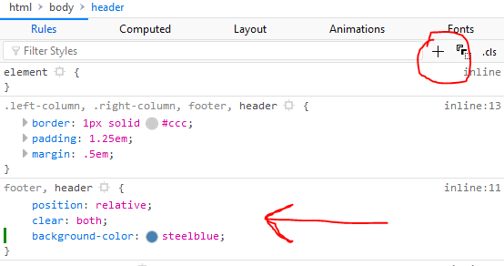

1. By pressing the plus icon while selecting the footer, header window, you can add a new style rule. Type background, press enter, then type color, press enter, and then type steelblue.
2. Do the same with the <a> tags, located under hear>nav>ul>li>a href. Press the plus sign for <a> and add a new style. Type color, press enter and type white.
3. 

After changing the header/footer for the page, your end result should resemble this:

